#Write a program to find input letter is alphabet
# digit or special character

ch=input("Enter any character")
if (ch>='A' and ch<='Z') or (ch>='a' and ch<='z'):
print("Alphabet")
elif ch>='0' and ch<='9':
print("Digit")
else:
print("Special Character")

Output
Enter any character7
Digit

Enter any character$
Special Character

Enter any characterB
Alphabet

Example:
# Write a program to convert input alphaet from
# uppercase to lowercase
# lowercase to uppercase

ch=input("Enter any letter ")
if ch>='A' and ch<='Z':
ch=chr(ord(ch)+32)
elif ch>='a' and ch<='z':
ch=chr(ord(ch)-32)
else:
print("input only alphabets")

print(ch)

Output
Enter any letter D
d

Enter any letter d
D

# Write a program to find input year is leap or not

year=int(input("Year :"))
if (year%4==0 and year%100!=0) or (year%400==0):
print(year,"leap year")
else:
print(year,"not leap year")

Output
Year :2024
2024 leap year

Year :2021
2021 not leap year

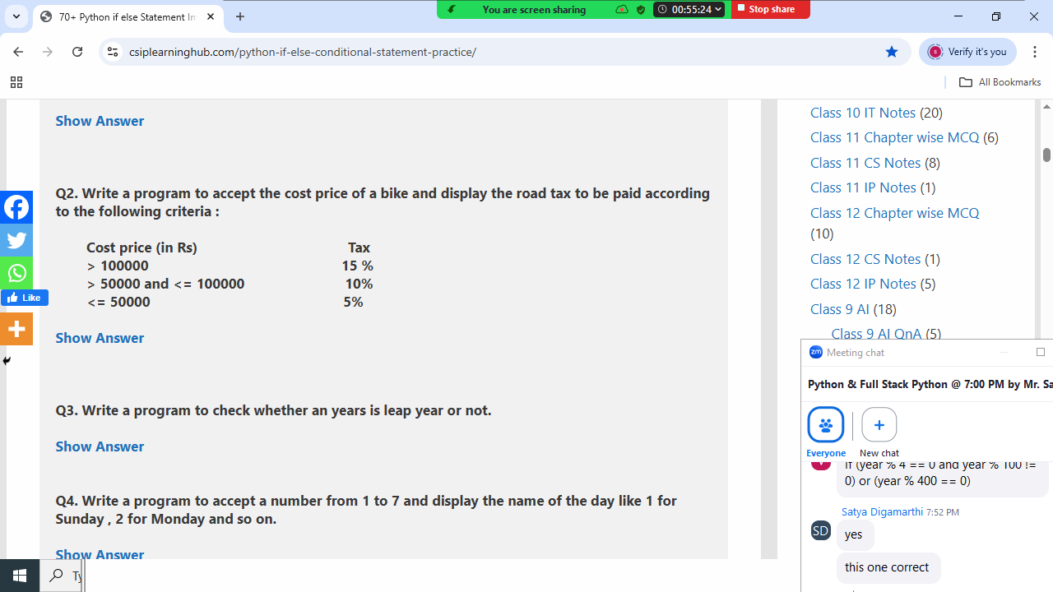

price=int(input("Bike Price :"))
if price>100000:
tax=price*15/100
elif price>50000 and price<=100000:
tax=price*10/100
else:
tax=price*5/100

print("Bike Price ",price)
print("Tax ",tax)
print("Total Cost ",price+tax)

Output
Bike Price :70000
Bike Price 70000
Tax 7000.0
Total Cost 77000.0

Bike Price :45000
Bike Price 45000
Tax 2250.0
Total Cost 47250.0

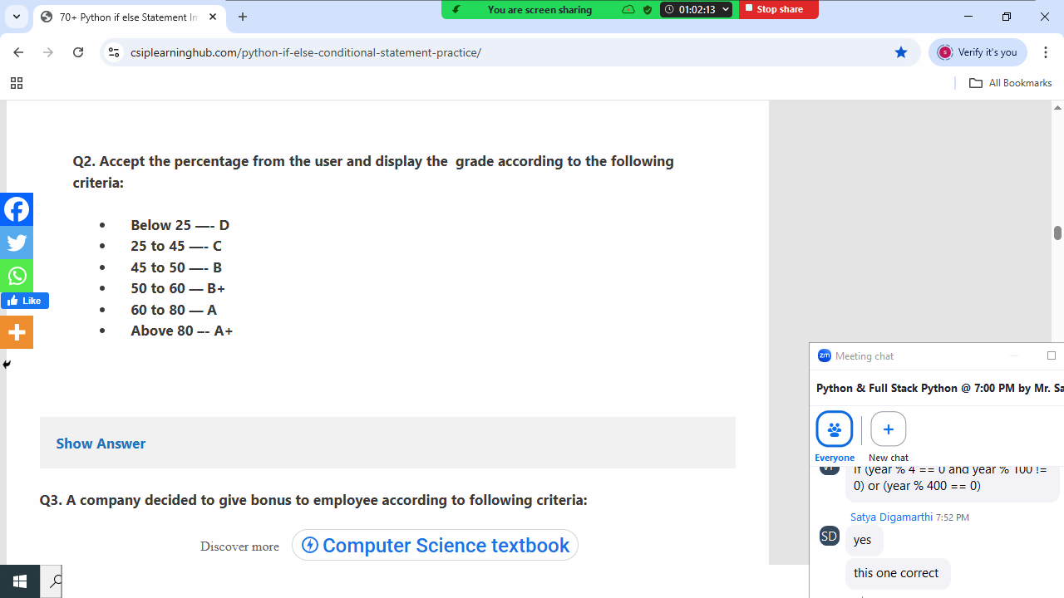
p=int(input("Percentage :"))
if p>80:
print("A+")
elif p>60 and p<=80:
print("A")
elif p>50 and p<=60:
print("B+")
elif p>45 and p<=50:
print("B")
elif p>=25 and p<=45:
print("C")
else:
print("D")

Output
Percentage :98
A+

Percentage :70
A

Percentage :30
C

Example:
# Write a program to find max of 3 numbers

n1=int(input("input first number "))
n2=int(input("input second number "))
n3=int(input("input third number "))
if n1>=n2 and n1>=n3:
print(n1,"is max")
elif n2>=n1 and n2>=n3:
print(n2,"is max")
elif n3>=n1 and n3>=n2:
print(n3,"is max")

Output
input first number 100
input second number 200
input third number 200
200 is max

input first number 100
input second number 100
input third number 100
100 is max

Nested if
Defined if inside if is called nested if (OR)
If followed by another if is called nested if (OR)
If within if is called nested if

Syntax:
If condition1:
If condition2:
Statement-1
else:
Statement-2
elif condition3:
If condition4:
Statement-3
Else:
Statement-4
else:
Statement-5

# Login application

user=input("UserName :")
pwd=input("Password :")
if user=="nit":
if pwd=="n123":
print("Welcome")
else:
print("Invalid password")
else:
print("invalid username")

Output
UserName :nit
Password :n123
Welcome

UserName :nit
Password :nit123
Invalid password

UserName :abc
Password :n123
invalid username

Example:
# Write a program to find input year is leap or not
# without using and, or operators

year=int(input("Enter any year :"))
if year%4==0:
if year%100==0:
if year%400==0:
print(year,"leap year")
else:
print(year,"not leap year")
else:
print(year,"leap year")
else:
print(year,"not leap year")

Output
Enter any year :2024
2024 leap year

Enter any year :2025
2025 not leap year

Match statement

